## horizontal line

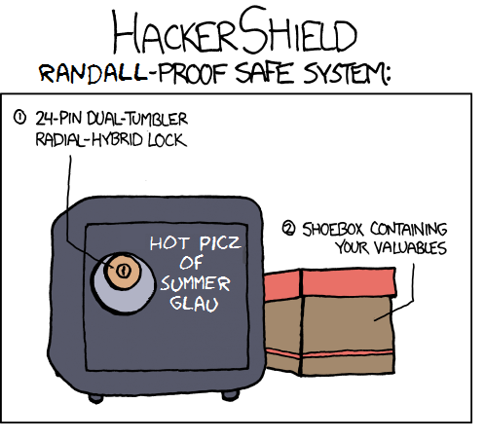

**Penetration Test Report**

04.20.2017 Performed by Alexander Cannell

**─**

Alexander Cannell

1337 West 3701 East

Cedar City, UT 84720/E: [alexandercannell@suu.edu](mailto:alexandercannell@suu.edu)/P: 867.5309

# **Table Of Contents**

**Document Revision History** **2**

**Executive Summary** **2**

**Summary Recommendations** **3**

**Narrative** **3**

**Findings** **3**

# **Document Revision History**

|  |  |  |
| --- | --- | --- |
| **Author** | **Version** | **Date** |
| Alexander Cannell | 1.0 | 04/12/2017 |
| Alexander Cannell | 2.0 | 04/20/2017 |

# **Executive Summary**

On April 20th 2017, Alexander Cannell performed a penetration test against the vulnerable MrRobot VM given to me by Ryan Linn. The purpose of the penetration test was to look into possible vulnerabilities on the MrRobot VM that could be exploited. Also the purpose of this exercise was to test new methods of attack, previous knowledge, and new tools in a professional way.

The MrRobot VM is an Apache web application running WordPress. The goal was to get all 3 text markers proving how far can you get within the MrRobot VM and how vulnerable the VM is. I was able to grab all three keys, and gain root/super admin rights on the MrRobot VM.

# **Summary Recommendations**

Based on the finding during the Penetration Test. The following recommendations will help improve your security.

* Securing/Encrypting these robot.txt, key-1-of-3.txt, fsocity.dic files, and other sensitive files.
* Use strong passwords
* Remove readme.html
* Admin over ssl
* Use limited access on any files that contain sensitive data like hashed passwords with usernames.
* Use better passwords
* Patch WordPress to the latest version
* Carefully audits and privileged programs and users
* Follows secure computing practices
* Get rid of the external urls of 10.0.2.5/robot.txt, 10.0.2.5/key-1-of-3.txt, and 10.0.2.5/fsocity.dic.

# **Narrative**

Once upon a time in a galaxy far far away, one man Alexander Cannell performs a penetration test on a MrRobot VM on April 20th 2017. Testing began by performing various network scans like Nmap and netdiscover. Which we identified the target 10.0.2.5 and what was running on the target which was apache. I proceeded to do a Nikto scan which is a web server scanner to discover several possible attack surfaces. On interesting one was /robots.txt, that lead me to grab a dictionary file and the first key with very little effort and authentication.

Further testing lead me to discover the second key, and escalate privileges to gain root privileges. I did this by using the tools wpscan and hydra to brute force a username and password. I then used that username and password to reverse shell into your machine. Using a found username and hash password found in a subdirectory under /home/robot I was able to escalate my privileges to cat the second key.

Using the new user I was able to use a Nmap interactive to escalate my privileges even further to root access which allowed me to grab the third and last key.

$nmap --interactive

Nmap --interactive

Starting nmap v.3.81 (<http://www.insecure.org/nmap/>)

Welcome to interactive mode -- press h <enter> for help

nmap> ! /bin/sh

! /bin/sh

#id

Id

uid=1002(robot) gid=1002(robot) euid=0(root) groups=0(root), 1002(robot)

#cd /root

Cd /root

#ls

Ls

Firstboot_done key-3-of-3.txt

#cat key-3-of-3.txt

Cat Key-3-of-3.txt

04787ddef27c3dee1ee161b21670b4e4

# **Findings**

The following are the findings discovered during this engagement. The criteria for rating these vulnerabilities follows:

* **Critical**: Remote exploitation is possible without authentication or exploitation is trivial and grants significant privileges
* **High**: Remote exploitation is possible without authentication but additional steps are needed to have a full compromise
* **Medium**: Exploitation is possible, but relies on additional attack vectors to be successful
* **Low**: Exploitation is extremely difficult to perform and may not be reliable.
* **Info**: Information that doesn’t directly lead to exploitation but may give away details to an attacker that will prove more useful in finding vulnerabilities or attacking systems

**Title:** Nikto Scan

**Vulnerability ID:** E0001

**Severity:** High

**Vulnerable Host:** Http://10.0.2.5/robot.txt

**Explanation:**

Server leaks inodes via ETags, header found with file /robots.txt, fields: 0x29 0x52467010ef8ad. I scanned the host 10.0.2.5 with Nikto Scanner which is a open source web server scanner. This allowed us to view the robot.txt file that pointed to the key and a fsocity.dic. I was able to wget both the key and fsocity files from the website.

**Evidence:**

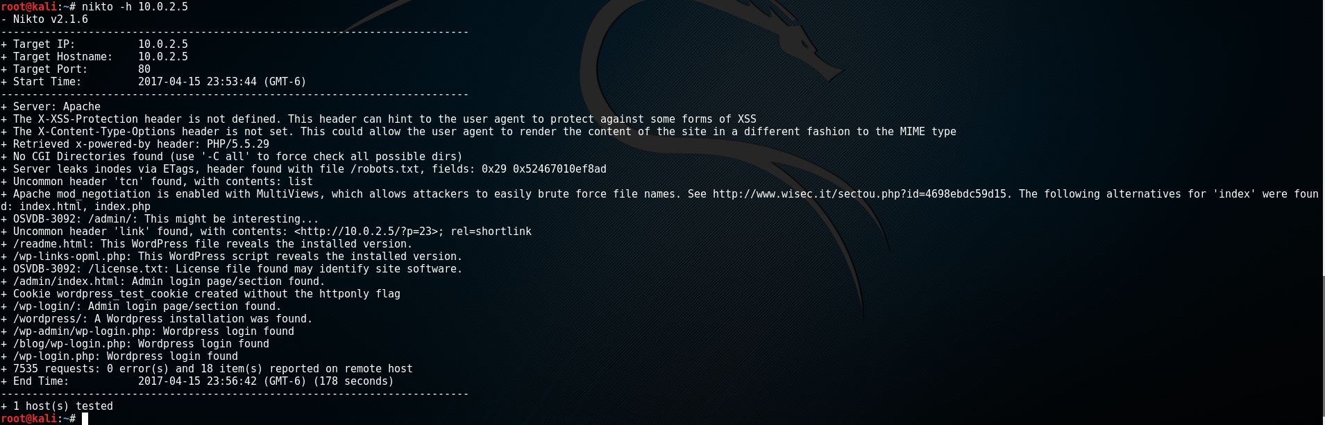

Figure 1: Search Results of Nikto

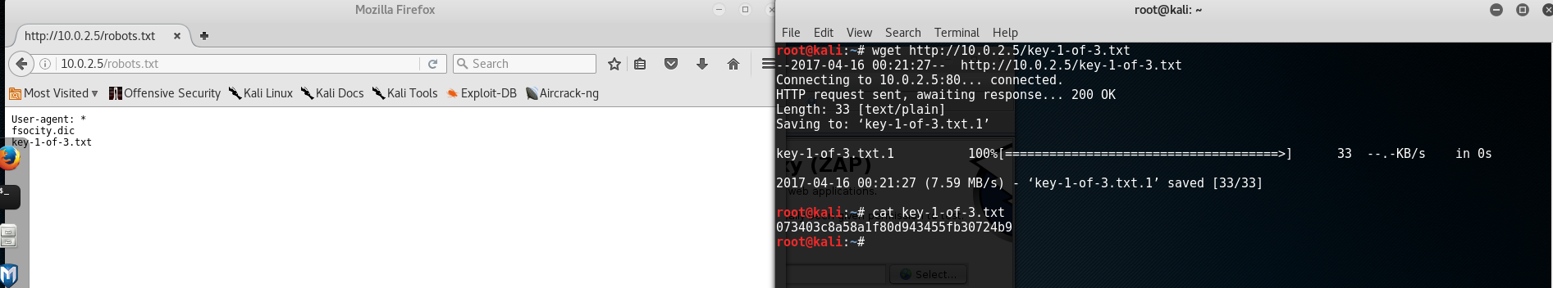

Figure 2: Download of the first key

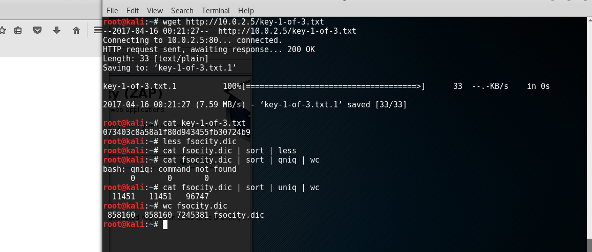

Figure 3: Cat-ing the dictionary Fsocity.

**Remediation:**

* Get rid of the external urls of 10.0.2.5/robot.txt, 10.0.2.5/key-1-of-3.txt, and 10.0.2.5/fsocity.dic.
* Securing/Encrypting these robot.txt, key-1-of-3.txt, and fsocity.dic files.

**References:**

<http://sectools.org/tool/nikto/>

<http://lifehacker.com/five-best-file-encryption-tools-5677725>

**Title:** WPScan/Hydra

**Vulnerability ID:** E0002

**Severity:** Medium

**Vulnerable Host:**  http://10.0.2.5/wp-login.php

**Explanation:**

Using the bruteforce software Hydra I was able to take the fsocity dictionary that we got earlier and test that against the wp-login php page to find a username. The username is Elliot. I was then able to find the password associated with Elliot by using wpscan to bruteforce the password ER28-0652. I then traversed to <http://10.0.2.5/wp-login.php> and logged into the Wordpress Editor with the newly acquired username and password.

**Evidence:**

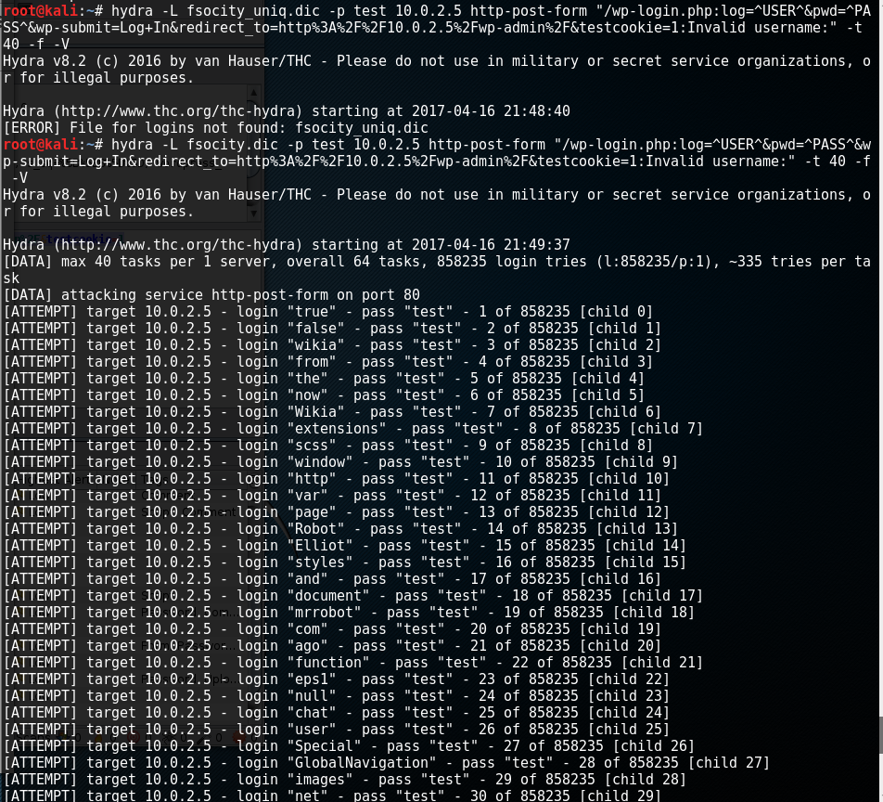

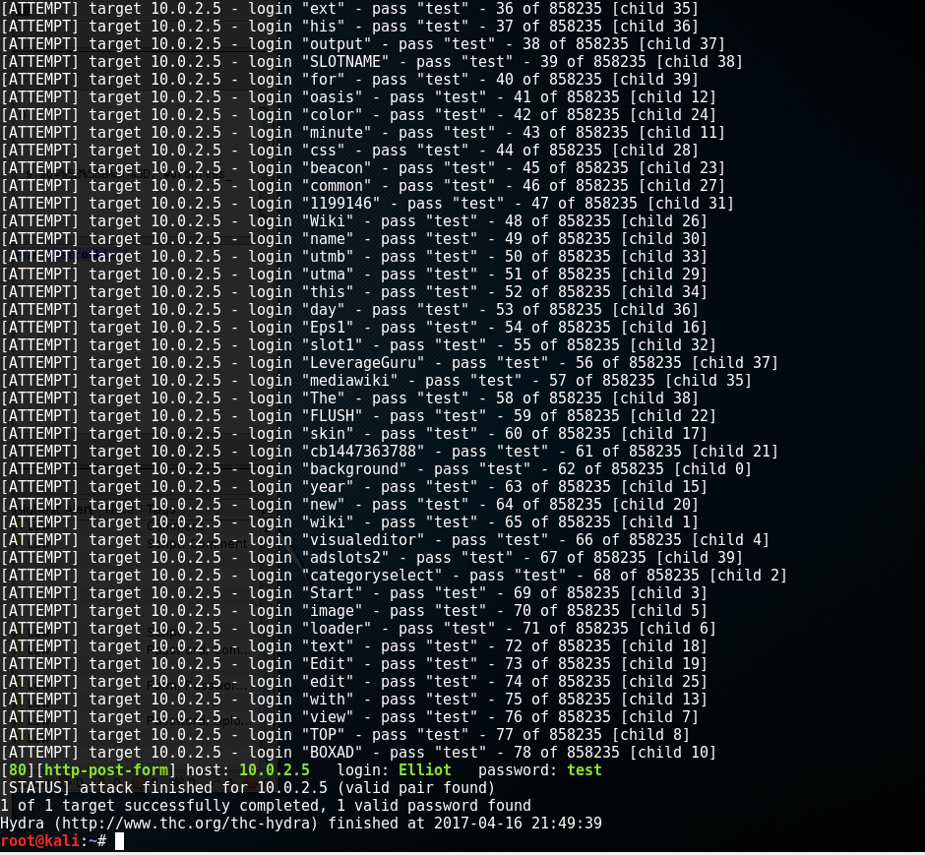

Figure 4: Using Hydra to get the User name.

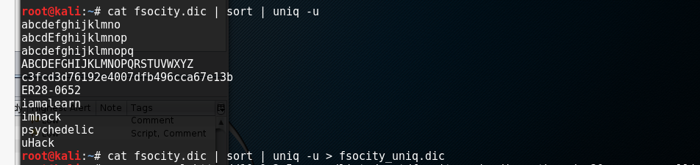

Figure 5: Taking all the unique words in fsocity.dic and putting that into a new dictionary file.

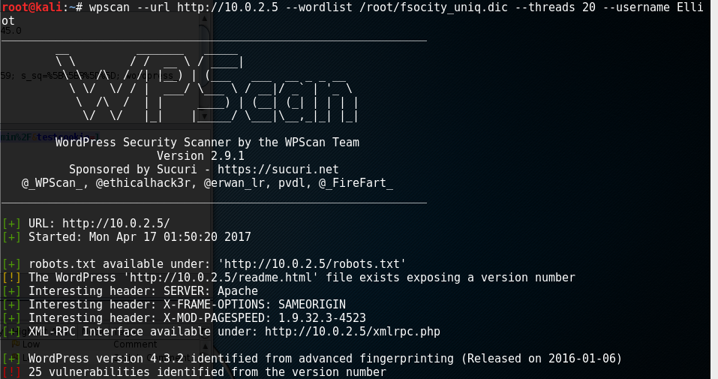

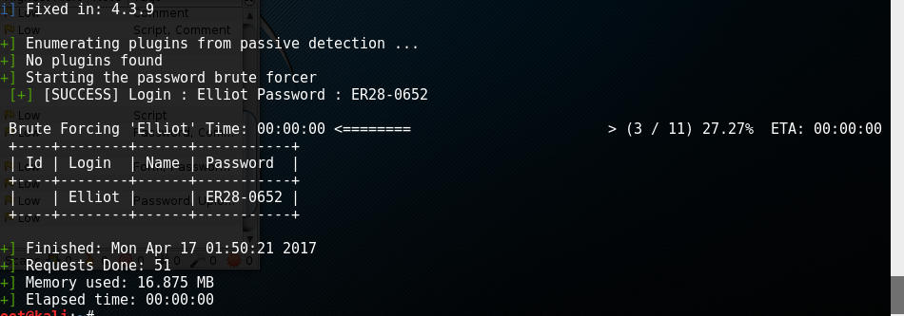

Figure 6: Bruteforcing the password for the user elliot.

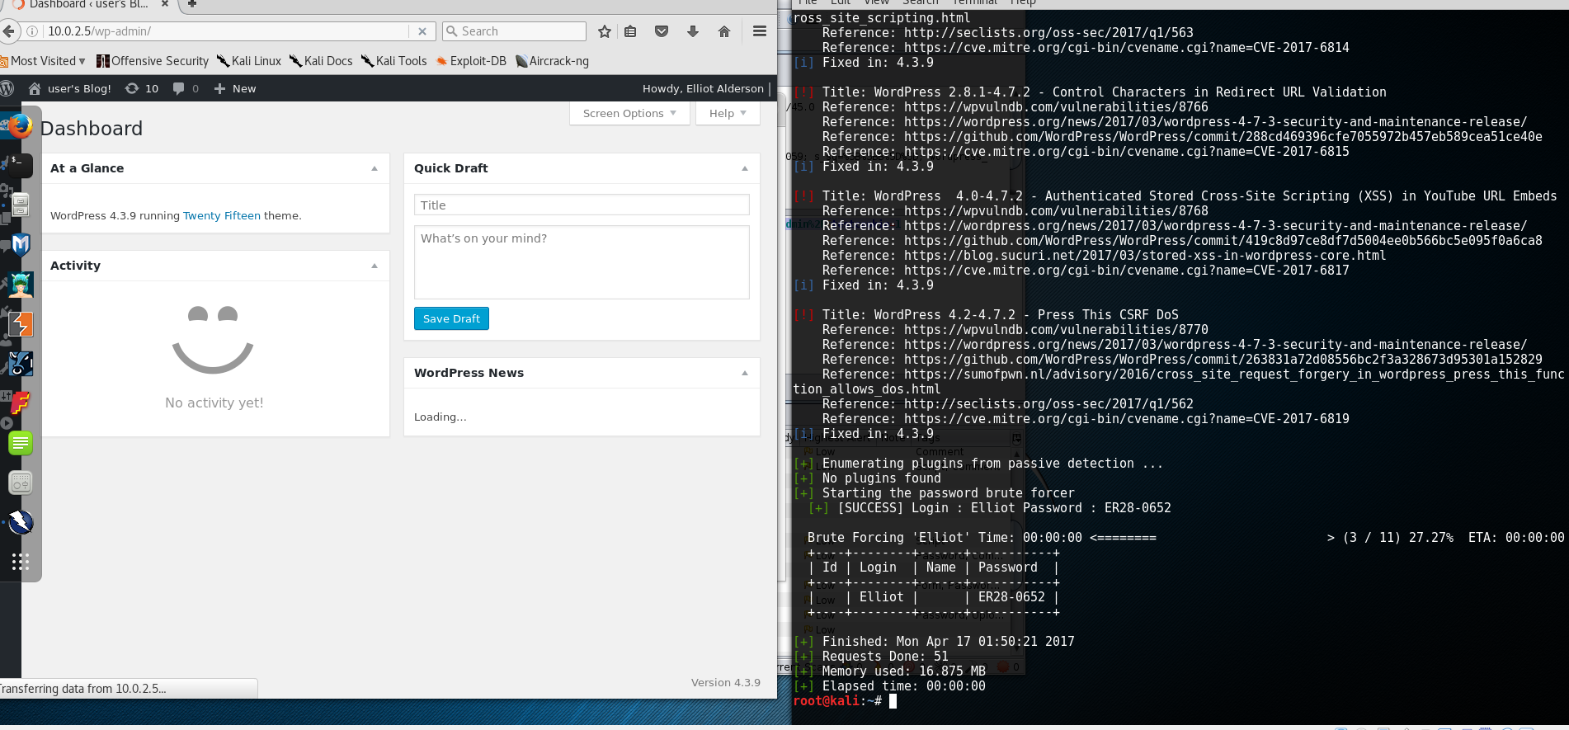

Figure 7: Proof of login success.

**Remediation:**

* Encrypt/secure the fsocity.dic file
* Update WordPress.
* Use strong passwords
* Remove readme.html
* Admin over ssl

**References:**

<https://wpscan.org/>

<https://security.szurek.pl/prevent-wpscan-from-scanning.html>

<https://github.com/wpscanteam/wpscan/wiki/WordPress-Security-Tips>

**Title:** wp_admin_shell_upload

**Vulnerability ID:** E0003

**Severity:** Critical

**Vulnerable Host:** http://10.0.2.5/wp-content/plugins/

**Explanation:**

Using the username and password obtained earlier, Elliot/ER28-0652. I was able to set up a reverse shell into the host. With the user Elliot I was able to traverse the box pretty well. I found several interesting files including “You will never guess this file's name”, the second key, and finally a hashed password and user. Using the amazing google I was able to unhash the password and gain further access to be able to open up the second key text file.

**Evidence:**

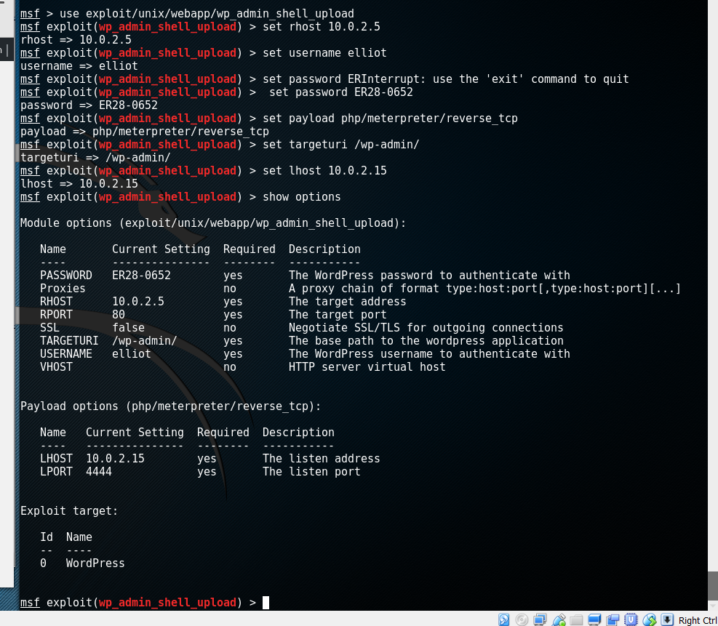

Figure 8: Shell Setup

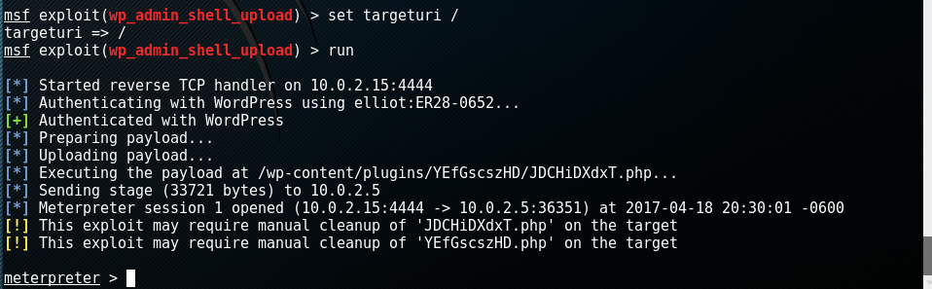

Figure 9: Proof of connected shell.

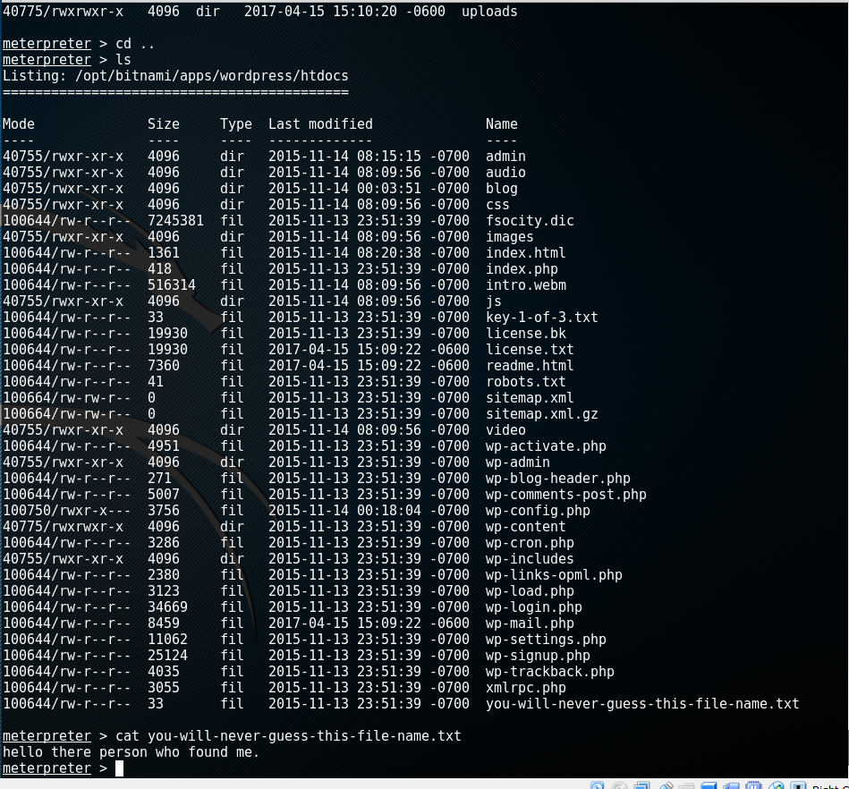

Figure 10: I found you…. Traversing the box.

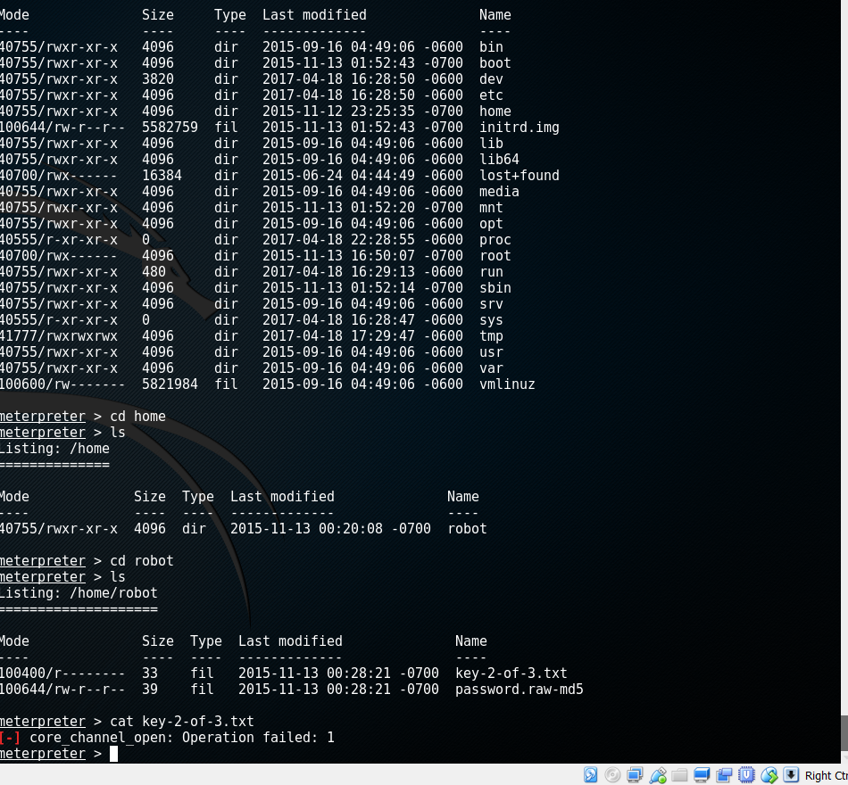

Figure 11: Finding the key-2-of-3.txt and password.raw-md5 files

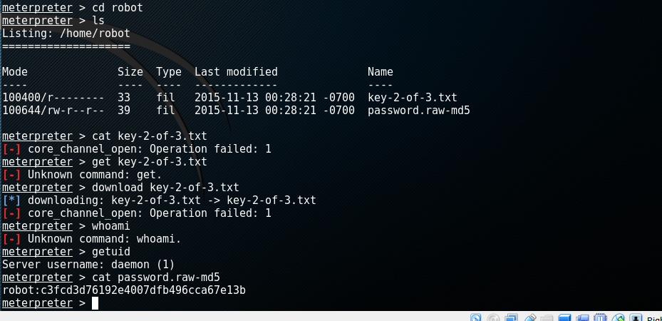

Figure 12: Cat-ing the hash and the associated username robot.

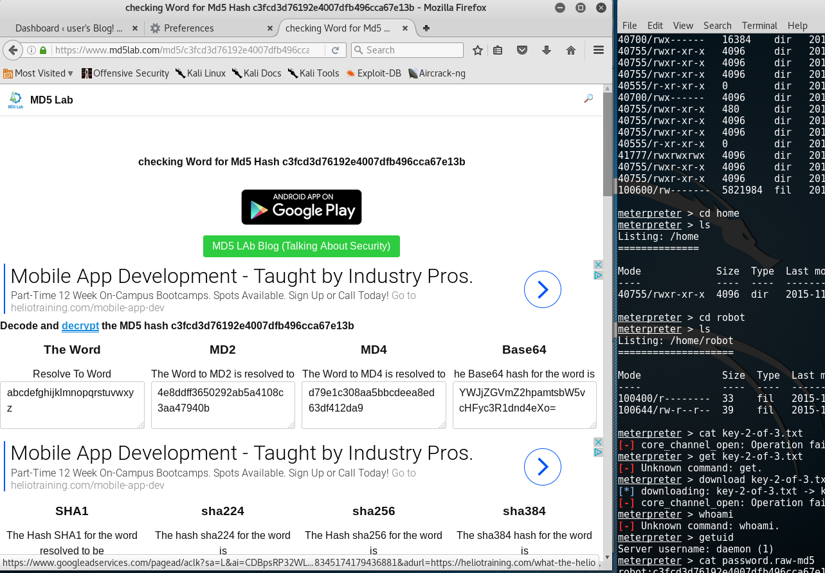

Figure 13: unhashed password is the alphabet.

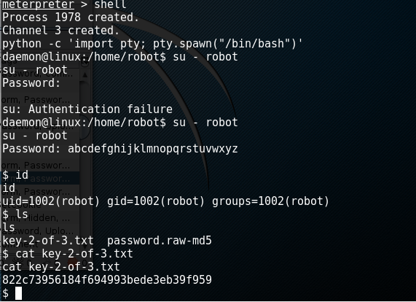

Figure 14: Accessing the key-2-of-3.txt file

**Remediation:**

* Use limited access on any files that contain sensitive data like hashed passwords with usernames.
* Encrypt Files
* Use better passwords
* Patch WordPress to the latest version

**References:**

<https://github.com/wpscanteam/wpscan/wiki/WordPress-Security-Tips>

<https://www.rapid7.com/db/modules/exploit/unix/webapp/wp_admin_shell_upload>

**Title:** NMAP Interactive

**Vulnerability ID:** E0004

**Severity:** Critical

**Vulnerable Host:** http://10.0.2.5/wp-content/plugins/

**Explanation:**

**Evidence:**

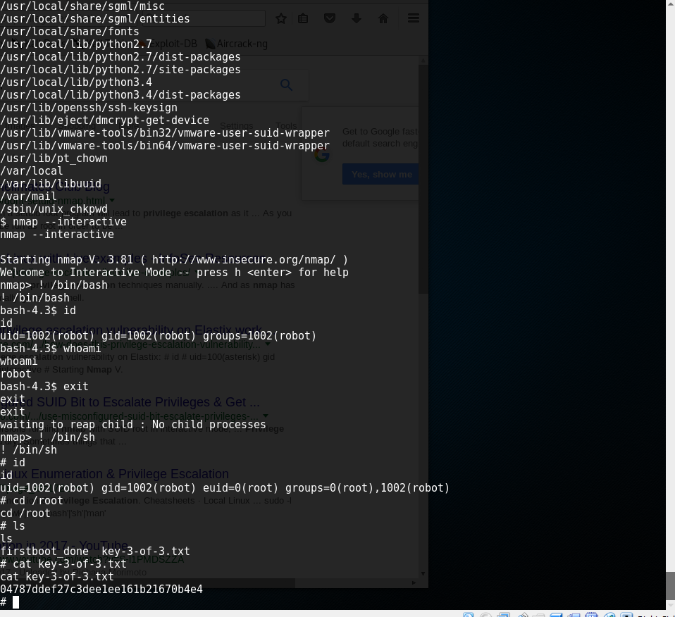

Figure 15: Using nmap interactive to escalate privileges to root

**Remediation:**

* Encrypt Files
* Use better passwords
* Patch WordPress to the latest version
* Admin over ssl
* Carefully audits and privileged programs and users
* Follows secure computing practices

**References:**

<http://resources.infosecinstitute.com/privilege-escalation-linux-live-examples/#gref>

<https://www.sans.org/reading-room/whitepapers/testing/attack-defend-linux-privilege-escalation-techniques-2016-37562>